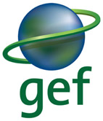

Annual Project Report 2017-2018

Project title: Generate global environmental benefits through environmental education and raising awareness of stakeholders.
Country: Armenia | Implementing Partner: Ministry of Nature Protection |  |  | Management Arrangements : Support to NIM
Atlas Project ID/Award ID number: 00081939 |  |  | Atlas Output ID/Project ID number: 00091047
UNDP-GEF PIMS ID number: 5309 |  |  | GEF ID number: 5716
Project start date (ProDoc signature date):  3-Nov-2015 |  |  | Original Planned project closing date: 3-Nov-2018
 |  |  | Revised project closing date: 3-Nov-2019
Financing Plan & Expenditures
Total GEF Grant (U$S): 750,000 |  |  | Total Co-financing (as planned in CEO endorsement request) (U$S): 723,735
GEF Grant Disbursed as of 30/06 (U$S):  326,522.84 |  |  | GEF Grant Annual Expenditures as of 30/06 (U$S):  2016: 45,834.81  2017: 138,172.98  2018: 142,515.05 (January-June, 2018)
Project Contacts and Links
Partner |  | Contact Name |  |  | Email Address
Project Coordinator / Manager |  | Armine Poghosyan |  |  | armine.poghosyan@undp.org
UNDP Country Office Programme Officer |  | Armen Martirosyan |  |  | armen.martirosyan@undp.org
Project Implementing Partner |  | MNP
GEF Operational Focal Point |  | Erik Grigoryan |  |  | erik.grigoryan@mnp.am
Other Partners |  | Ministry of Education and Science (Senior Beneficiary)
UNDP Technical Adviser |  | Mr. Tom Twining-Ward |  |  | tom.twining-ward@undp.org
UNDP Programme Associate |  | Ms. Eva Huttova |  |  | eva.huttova@undp.org
Project website, etc. |  | http://www.am.undp.org/content/armenia/en/home/operations/projects/environment_and_energy/generate-global-environmental-benefits-through-environmental-edu.html
Links to media coverage |  | UNDP Armenia Facebook Page https://www.facebook.com/UNDPArmenia/  UNDP Armenia Twitter Page https://twitter.com/UNDPArmenia/status/978531669882949632 (Coverage of implemented training on “Environmental Law”)  https://www.facebook.com/UNDPArmenia/posts/%D5%BD%D5%A5%D5%BA%D5%BF%D5%A5%D5%B4%D5%A2%D5%A5%D6%80%D5%AB-12-%D5%AB%D5%B6-%D5%BF%D5%A5%D5%B2%D5%AB-%D5%B8%D6%82%D5%B6%D5%A5%D6%81%D5%A1%D5%BE-%D5%A7%D5%AF%D5%B8%D5%AC%D5%B8%D5%A3%D5%AB%D5%A1%D5%AF%D5%A1%D5%B6-%D5%AF%D6%80%D5%A9%D5%B8%D6%82%D5%A9%D5%B5%D5%A1%D5%B6-%D6%87-%D5%B7%D5%A1%D5%B0%D5%A1%D5%A3%D6%80%D5%A3%D5%AB%D5%BC-%D5%AF%D5%B8%D5%B2%D5%B4%D5%A5%D6%80%D5%AB-%D5%AB%D6%80%D5%A1%D5%A6%D5%A5%D5%AF%D5%BE%D5%A1/1467898319958099/  (Coverage of implemented training on “Environmental Law”)  RoA Ministry of Nature Protection  http://mnp.am/am/post/3138 (Article on implemented exhibition entitled “Facing the Climate: Swedish and Armenian satirical cartoonists get you thinking”)  http://mnp.am/am/post/2871 (Article on organization of the national workshop on “Re-orienting technical and vocational education and training through education for sustainable development to support sustainable development and transition to a green economy in the Republic of Armenia”)
Brief project summary:
This project is in line with the following CCCD Programme Objectives: CD2 - to generate, access and use information and knowledge; and CD4 - to strengthen capacities for management and implementation on convention guidelines. It is also aligned with the second and third objective of the GEF-6 CCCD strategy that is to (i) strengthen consultative and management structures and mechanisms; and (ii) Integrate MEAs provisions within national policy, legislative, and regulatory frameworks. It is a direct response to the GEF-funded National Capacity Self-Assessment (NCSA) project conducted in Armenia during the period of 2003-2004 and particularly a direct response to a governmental measure that was calling for the “organization of continuous education and awareness raising activities for the public on issues related to Conventions. Develop and implement educational projects on the elaboration of the local environmental projects, methods and activities of sustainable use of natural resources for local self-administration bodies”. Through a learning-by-doing process, this project will strengthen the capacities of key individuals and institutions to use environmental education and awareness raising as tools. By extension, better environmental skills and knowledge will be available in Armenia, which should in turn deliver greater global environmental achievements over the medium and long-term. The first component will address the capacity gaps of the existing enabling environment that is preventing environmental education of being effectively used as a tool by stakeholders involved in natural resource management. The second component will be used to mainstream environmental education into national strategies, programmes and projects, and also to develop environmental education programmes as well as sustainable delivery mechanisms targeting staff in the public sector and educators in Armenia. Finally, the third component will be used to develop the capacity of CBOs and of the media – including journalists - to use environmental education and awareness raising as tools for conducting information awareness and environmental education activities at the community level but also at the national level through a national campaign.
Link to Project QA assessment implementation report for the reporting period: |  |  | UNDP Quality Assurance System (QA)  https://intranet.undp.org/sites/ARM/project/00081939/SitePages/ProjectQAHomeV2.aspx?year=2017&ipp=0&dfs=APPROVED&cfs=

I. Executive Summary
(one page maximum)
A concise brief on the progress towards the Project key deliverables, and outputs (project output is the same as CPAP output), related to Country Programme Outcome and SP Output and Outcome during the reporting period. The section should also include key results related to the capacity development, gender equality (marker), environment and social safeguard, partnership, South-South and Triangular Cooperation efforts, implementation issues/challenges and the main lessons learnt.
UNDP-GEF “Generate global environmental benefits through environmental education and raising awareness of stakeholders” project was officially launched in June 2016. The Project functions under the management of the Project Coordinator/ SGR portfolio analyst and Technical Task Leader with the support of the Project Assistant. Within the reporting period of July 2017 – June 2018 the project delivered the following significant results:
- Developed “National Strategy on Environmental Education and Upbringing” approved by the RoA Government in February 2018 and launched the development of a package on legal instruments/amendments related to Environmental Education;
- Developed materials and conducted two workshops on “Environmental Law” for 20 representatives of governmental entities and 20 mass media and CBOs representatives.
- Completed Training Needs and Capacity Assessments among governmental sector staff and self-governing bodies, educational institutions, CBOs and media in the Environmental Education (EE) area;
- Completed the development of 11 modules on EE for decision-makers;
- Developed Environmental Disaster Risk Reduction training materials and conducted ToT for 26 professors/lecturers from higher educational entities and CBO representatives;
- Supported the delivery of training sessions by CBOs through Micro-Capital grant modality;
- Established cooperation with UNDP Russia Trust Fund for Development & leveraged USD 50,000 for customizing, adapting and introducing in the educational sector the “Climate Box” Project.
The Project encountered certain challenges and respective delays, related to ongoing full scope institutional reforms RoA Civil Service Council and civil service system of the RoA expected to be finalized by the end of 2018, as well as due to force majeure political changes and resignation of Government in April-May 2018, the Project activities related to enhancing legal, policy, institutional frameworks have been postponed till the formation of the new government and stabilization of the situation in the country.
The project mid-term evaluation (MTR) was carried out by an independent international consultant. The MTR was finalized in February 2018, respective Management response was developed respectively. Following the MTR recommendation and the Project Board no-objection, the Project requested no-cost extension, which was granted for 12 months period. Respective revisions of the project budget and work-plan were conducted.

II. Implementation Progress

Progress toward Development Objective:
For each indicator, the Project Manager should enter the cumulative progress since project start directly into the box in the far right column.
Objectives and Outcomes | Indicator | Baseline | Targets  End of Project | Status of implementation
Objective: to strengthen the capacity to use environmental education and awareness raising as tools to address natural resource management issues. | - Use of EE and environmental awareness tools to address NRM | - These tools & techniques on EE and EA are rarely used for NRM in Armenia | - Diverse and high quality EE and EA programmes are available to address NRM | - Ongoing
 | - Citizens involvement in decision-making to address NRM issues | - Few opportunities for stakeholder involvement in NRM decisions at national or community levels | - Stakeholders in selected areas are involved in decision-making to address NRM issues | - Ongoing
 | - Decision-makers and teachers able to use EE as a tool to improve NRM. | - Few key stakeholders have the capacity to use EE as a tool to address NRM issues | - Decision-makers and teachers using EE as a tool to improve NRM | - Ongoing
 | - Capacity development scorecard rating | Capacity for:  - Engagement: 5 of 9  - Generate, access and use information and knowledge: 7 of 15  - Policy and legislation development: 6 of 9  - Management and implementation: 3 of 6  - Monitor and evaluate: 3 of 6  (Total score: 24/45) | Capacity for:  - Engagement: 7 of 9  - Generate, access and use information and knowledge: 11 of 15  - Policy and legislation development: 7 of 9  - Management and implementation: 4 of 6  - Monitor and evaluate: 4 of 6  (Total targeted score: 33/45) | - N/A for this period
OUTCOME 1: Enhanced legal, policy, institutional and strategic frameworks to strengthen environmental education and raising awareness of stakeholder as natural resource management tools.
Output 1.1: Adequate legislation and policy frameworks are in place to implement obligations from the Rio and Aarhus Conventions related to environmental education and public awareness.  Output 1.2: Relevant institutions have the necessary mandates to use environmental education and public awareness as tools for environmental management. | - Adequate policies for EE in place integrating Rio and Aarhus Conventions’ obligations | - Current policies are poorly known, weakly implemented and do not include EE as an effective tool to address NRM issues. | - Key policies for EE in place integrating Rio and Aarhus Conventions’ obligations and providing an conducive enabling environment for the development of EE in Armenia | - “National Strategy on development of Ecological Education and Upbringing” was developed and approved by the RoA government. http://www.irtek.am/views/act.aspx?aid=93900  - The website for Extractive Industries Transparency Initiative (EITI) for Armenia was developed (https://www.eiti.am/en/)  - 500 copies of Red Book of Animal and Plant of the Republic of Armenia were published  - 2 animation films on implementation of UN Convention of Biodiversity and UN Framework Convention on Climate Change were developed, two (2) draft animations are produced.
 | - Adequate legislation for EE in place | - Current Law on environmental education as well as related laws are not conducive to the use of EE as a tool for NRM | - EE as a tool for NRM is supported by a conducive legislation framework | - Development of a package on legal instruments/amendments related to Environmental Education (EE) has been launched
 | - Adequate institutional set-up with clear mandate to carry out EE activities | - Weak institutional mandates, weak national coordination and unclear responsibilities for EE | - Institutions with clear mandates and assigned responsibilities to implement EE programmes | - Training materials were developed and one workshop on “Environmental Law” for 20 (9 M and 11 F) representatives of governmental entities was conducted.
OUTCOME 2: Improved capacity of relevant government and educational entities to integrate environmental education and awareness raising into programmes and projects as tools for natural resource management.
Output 2.1: Capacity enhanced of key government and educational entities to integrate environmental education and public awareness into programmes and projects.  Output 2.2: Integrated training programmes developed and delivered through training centers for civil servants; training centers for teachers and other existing relevant training mechanisms. | - Strategies and programmes integrating EE and public awareness as tools to improve NRM | - Current strategies and programmes do not include EE as a tool to address NRM issues. | - Key strategies and programmes includes EE as a tool to address NRM issues and solutions, including integration of Rio and Aarhus Conventions’ obligations | - Training needs assessment (TNA) to identify capacity gaps of governmental sector staff and self-governing bodies in the Environmental Education area is finalized. 112 respondents, representing 9 key Ministries involved in natural resource management, all 10 Regional Administrations, 69 Local Self-Governance Bodies of Municipalities of regional towns and rural communities, as well as Yerevan Municipality, were involved in the survey.  - Existing training programs for civil and community servants in Armenia were studied and proposal with practical recommendations for mainstreaming EE into the training programs for Civil and Community servants in Armenia was developed.  - Development of a package on recommendation to integrate (EE) into National Strategies has been launched
 | - Number and diversity of organizations and individuals trained (men and women) to deliver EE programmes | - Few key stakeholders are trained to develop and deliver EE programmes in Armenia | - 50 key stakeholders in different organizations are trained to deliver EE programmes with a minimum of 40% women | - The methodology was developed and Capacity and Needs Assessment of 13 Higher educational institutions in the field of EE was completed.  - Environmental Disaster Risk Reduction training materials were developed and training for 26 (7 M and 19 F) professors/lecturers from educational institutions and representatives of CBOs was conducted
 | - Quantity and quality of EE materials and delivery mechanisms | - EE training materials for civil servants is very limited  - Limited EE training delivery mechanisms targeting civil servants  - Existing EE programmes to train teachers in pedagogical universities  - Uneven delivery of these EE programmes to teachers, particularly practicing teachers | - EE programmes and delivery mechanisms available to public servants and practicing teachers | - Eleven (11) training modules for decision-makers involved in natural resource management were developed and validated through focus group discussion and Project Advisory Committee.
 | - Number of participants (men and women) trained in EE | - Limited training currently offered | - 1,000 people trained (civil servants and teachers) with a minimum of 40% women | N/A for this period
OUTCOME 3: Developed capacity of community based organizations (CBOs) to use environmental education and awareness raising as tools for natural resource management.
Output 3.1: Capacity enhanced of CBOs to implement environmental education and public awareness campaigns.  Output 3.2: Environmental education material is developed and delivery mechanisms are identified.  Output 3.3: A Communication campaign developed and delivered through community based activities and national media. | - Increased use of environmental awareness techniques in programmes and projects to address NRM and poverty reduction at the community level | - NGOs, CBOs and local governments use very little EE techniques | - NGOs, CBOs and local governments are using EE as a tool to make communities environmentally aware and to involve them in addressing NRM issues | - Capacities and need assessment of CBOs and media in the field of EE. An assessment covering 23 environmental CBOs, 15 non-environmental CBOs, as well as 15 media outlets was conducted. The desk research on the coverage of environmental issues by the mainstream media outlets (with highest number of audience) for the period from July 2016 to July 2017 was completed in August 2017. The results of assessment and report on desk research were presented during the first Advisory Committee meeting on 12 September 2017 for further consideration.
 | - EE and awareness material developed and use by delivery mechanisms | - Numerous materials on EE exist in Armenia but there is no common approach to deliver EE covering global environmental issues and solutions | - Existence of EE programmes delivered by strengthened delivery mechanisms | - Three (3) regional CBOs were contracted to implement projects under Micro-capital Grant Modality:  - “Generation of Light” Educational Foundation, “Nature is God’s gift to human: The Lord and steward of nature” Project. Generation of Light” Educational foundation published informative-analytical booklet “Nature is God’s gift to human: the lord and steward of nature” in 1000 copies (which is planned for dissemination among training participants.  - “Third Nature” NGO: “The increasing knowledge on the innovative model of electricity generation and distribution at the community level will bring the opportunity to mitigate climate change” Project. 3) educational booklets , covering the topics of: i) Energy cooperatives; ii) Local smart networks/Micro-networks; iii) Change in energy and climate change; Informative sessions/meeting were held in 15 rural communities of Shirak Marz and dissemination of awareness raising materials was conducted. Overall, 196 local residents (43F and 153M) participated in the meetings.  - “NGO Center” Civil Society Development NGO: “Better informed and responsible community” Project. “NGO Center” Civil Society Development NGO organized 3 move screenings and 6 trainings with participation of 152 representatives from local 6 communities. The trainings covered various topics related to environmental issues and natural resources management.  - Cooperation was established with Russian Trust Fund and $50,000 was leveraged by the Project for customizing and adapting “Climate Box” Project aimed at raising environmental literacy of mid-school aged youngsters. The Project will be implemented in 8 counties for the period of 2017-2019. Project budget for Armenia is estimated in the amount of 85,000.00 USD (Russian Trust Fund: 50,000.00 USD, Project co-funding (in-kind & cash): 35,000.00 USD). Implementation of the “Climate Box” (CB) Project was launched, including the translation of the manual into Armenian.
 | - A communication campaign developed and delivered | - Skills and knowledge to develop such campaign is currently limited in Armenia | - A communication campaign delivered and covering global environmental issues and solutions | - Development and facilitation of communication/public awareness campaigns related to implementation of three Rio Conventions and Aarhus convention in Armenia was launched.
 | - Number of journalists (men and women) and diversity of media outlets trained to deliver EE programmes | - Journalists and their media outlets have limited capacity to inform the public on NRM issues, including global environmental issues and solutions | - 100 journalists with a minimum of 40% women linked to a diverse number of media outlets trained in environmental awareness, including global environmental issues and solutions | - Training materials were developed and one workshop on “Environmental Law” for 20 (8 M and 12 F) mass media and CBOs representatives was conducted.

Key outputs delivered during reporting period:
Project Outcome | Key Outputs
OUTCOME 1: Enhanced legal, policy, institutional and strategic frameworks to strengthen environmental education and raising awareness of stakeholder as natural resource management tools. | - In support to the RoA Ministry of Nature Protection “National Strategy on Environmental Education and Upbringing” was developed. The latter was approved by the RoA Government in February 2018.  - The Project supported the RoA Government to develop Extractive Industries Transparency Initiative (EITI) website for Armenia aimed at enhancing the implementation of Aarhus Convention by assisting to effective, transparent and accountable management of natural resources and solving environmental issues, as well as public participation in environmental decision-making.  - 4 short animations on implementation of Rio Conventions and Aarhus convention in Armenia completed.  - Workshop on “Environmental Law” for 20 representatives of governmental entities was conducted.  - “The Red Book of Armenia” was published in 500 copies and distributed among key counterparts and stakeholders to increase awareness of decision-makers on biodiversity protection.
OUTCOME 2: Improved capacity of relevant government and educational entities to integrate environmental education and awareness raising into programmes and projects as tools for natural resource management. | - Training needs assessment (TNA) was conducted to identify capacity gaps of governmental sector staff and self-governing bodies in the Environmental Education. 112 respondents, representing key Ministries involved in natural resource management and Local Self-Governance Bodies were involved in the survey. The recommendations received were extensively used for the development of training materials and modules.  - Capacity and needs assessment of 13 tertiary educational institutions was conducted. The findings were inter alia used for developing the tertiary education component of the “National Strategy for Ecological Education” and preparation of Training of Trainers course.  - Development of eleven (11) training modules for decision-makers involved in natural resource management completed. The training materials are developed with consideration of behavioural science aspects and expert’s recommendations on how to influence the pro-environmental behavior of the public and decision makers.  - Training materials on “Environmental Disaster Risk Reduction” were developed and used in the scope of the organized workshop with participation of 26 professors/lecturers from higher educational entities and CBOs.
OUTCOME 3: Developed capacity of community-based organizations (CBOs) to use environmental education and awareness raising as tools for natural resource management. | - Capacity and need assessment of 38 environmental and non-environmental CBOs, and 15 mass media outlets was conducted. In addition, a desk research on the coverage of environmental issues by the main media outlets. The findings were inter alia used for developing the informal and non-formal educational, as well as public awareness components of the “National Strategy for Ecological Education” and for targeting gaps for capacity development of CBOs and mass media.  - As a result of announced “Environmental Education Challenge” call three (3) regional CBOs were selected to receive financial support under the Mico-capital grant modality to implement Environmental Education and public awareness raising projects. As a result more than 300 representatives from the local communities and different levels decision makers participated in workshops, conducted by selected CBOs.  - 20 representatives of mass media and CBOs were introduced to the basics of Environmental Law.

III. Project Implementation Challenges
Please identify and analyse project critical risks and project issues that:
1) had an impact on project deliverables (quality, schedule) during the reporting period, or
2) were newly identified during the reporting period and are being addressed by the project (in the case of risks, describe project prosed means to mitigate their effects or decrease the likelihood of impact in the future, and in the case of issues, how to resolve them).
a. Updated project risks and actions
P- Probability, I Impact – high – low

The Project does not have any identified Critical risks. Despite the recent changes in the Government and key stakeholders, Environmental Education is prioritized by the newly established Government. The Risk Log is updated in ATLAS and necessary changes are reflected.

b. Updated project issues and actions
Explain the main implementation issues encountered in the course of implementation during the year and the proposed actions to solve the issues.
Project Issue Description | Mitigation Measures, Actions Taken
Enter a brief description of the risk | What actions will be taken to mitigate this risk
The internal political crisis which led to significant changes in Government, may cause delays in project implementation and delivery. | The Project will shift the delayed activities for the remaining period due to the fact that the Project was extended for 12-months period. The Project will ensure close collaboration with new counterparts, as well as monitor the implementation process against approved workplan to avoid any further delays.
The proper incorporation of Environmental Education (EE) into the regular training programme for civil and community servants largely depends on on-going reforms on national level, particularly: i) full scope institutional reform of the RoA Civil Service Council and civil service system of the RoA, as a result of which by the end of 2018 - introduction of new training system for civil servants; ii) administrative-territorial reforms undertaken by the RoA Ministry of Territorial Administration and Development aimed at consolidation of communities to be completed by the end of 2018, which significantly influencing target groups (e.g. community servants) to be involved into the mandatory training for self-governing bodies. | The Project will shift the delayed activities for the remaining period due to the fact that the Project was extended for 12-months period. The Project will adjust working modalities to fit with the institutional reforms.
Adoption of new training programme for civil and community servants by governmental entities is comprised of several time-consuming stages, thus the Project will require additional time to complete the planned activities. | The Project will shift the delayed activities for the remaining period due to the fact that the Project was extended for 12-months period. The Project will ensure close monitoring of the implementation process against approved workplan to avoid any further delays.

IV. Annexes
Meetings/workshops minutes/reports, Knowledge products, Lessons Learnt, Gender analysis, etc.
Annex A – Agenda, List of Participants and Minutes of the Project Board Meeting, 28 September 2017
Annex B – Agenda, List of Participants and Minutes of the Project Board First Meeting Inception workshop minutes, 27 December 2017
Annex C – Project Infographics
Annex D – Summary of modules

Annex A. Agenda, List of Participants and Minutes of the Project Board Meeting

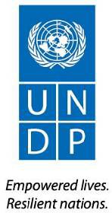
UNDP-GEF “Generate global environmental benefits through environmental education and raising awareness of stakeholders”

PROJECT BOARD FIRST MEETING
Venue: UN House in Armenia, 316 Room (14 P. Adamyan St.) Date: 28 September 2017
Time: 15:00-16:30

Participants

Project Board Members
1. | Mr. Armen Vardanyan | Head of Information and Public Relations Department, RoA Ministry of Nature Protection, Project Board Co-Chair
2. | Mr. Robert Stepanyan (Replaced by Representative of the RoA MoES) | Head of the Department of the Development Programme and Monitoring, RoA Ministry of Education and Science, Project Board Member
3. | Mr. Dmitry Mariyasin | Deputy Resident Representative, UNDP Armenia, Project  Board Co-Chair
Observers/Participants
4. | Mr. Armen Martirosyan | UNDP, SGR Portfolio Analyst, Project Coordinator
5. | Mr. Georgi Arzumanyan | UNDP, SGR Portfolio Programme Policy Advisor
6. | Mrs. Tatevik Koloyan | UNDP, SGR Portfolio Programme Associat
7. | Mrs. Armine Poghosyan | UNDP-GEF Project Technical Task Leader
8. | Ms. Tatevik Markosyan | UNDP-GEF Project Assistant
9. | Interpreter

Agenda:

‐ Project Overview and Project Progress over 2016-2017
‐ Annual Work Plan (2017-2018)
‐ Discussion/ Approval

Documents presented:

‐ Documents bilingual package was circulated electronically among all participants
(Standard progress report; draft work-plan 2017-2018) (English and Armenian)
‐ Project Reference Note (Armenian and English)
‐ Work-plan (English and Armenian)
‐ 1 PP Presentation

On behalf of the Project Board members welcoming remarks were delivered by Mr. Mariyasin. Mr. Martirosyan thanked the participants for attendance and very briefly presented the key discussions of the agenda, introduced developed Inforgraphics and encouraged to provide comments/feedback regarding the presented material. Mr. Vardanyan thanked for invitation, informed that he was participating for the first, however he was well aware on Project progresses, specifically the conducted Training Need Analysis (TNA) and results. Representative of the RoA Ministry of Education and Science also welcomed and informed that the Ministry overall encourages any initiatives aimed at capacity building and awareness raising, thus this Project was very timely and important. Mr. Mariyasin highlighted the importance of collaboration of two Ministries in the scope of the Project. The meeting agenda was accepted.

SECTION I. “Project Progress over 2016-2017” (by A. Poghosyan, Environmental
Education Project Technical Task Leader)

Mrs. Poghosyan presented the Project progress over 2016-2017, highlighted major activities, progresses and outputs achieved for the reporting period, with specific focus on conducted activities: i) Training Needs Assessment (TNA) of governmental sector and self-governing bodies conducted by “AM Partners”, ii) Assessment of CBOs and Mass media, iii) Assessment of Educational Institutions. Further, the ongoing activities were also provided: i) Development of modules/training materials by “AUA Acopian Center for Environment; ii) involvement of a Behavioural Scientist for ensuring behavioural aspects in the development of training materials, iii) Development of National Strategy of Environmental Education, iv) Development of a portal for Extractive Industry Transparency Initiative (EITI) etc. The established and anticipated collaborations were also presented i) Russian Trust Fund – “Climate Box” initiative; ii) Russian Trust Fund – organization of trainings for journalists, iii) DRR Project – establishments of community centers.

Mrs. Poghosyan also presented the work-plan for 2017-2018.
Mr. Mariyasin thanked for the presentation and opened a brief discussion and Q&A session.

➢ The Representative of the MoES enquired if the developed Modules/ Training Materials will vary based on the target beneficiaries.

‐ Mrs. Poghosyan clarified that the modules will be different based on the specifics and needs of the target beneficiaries. The earlier conducted TNA will serve for a good basis for differentiating and offering respective modules.

➢ Mr. A. Vardanyan highlighted the public awareness component of the Project. Mr.
Vardanyan enquired about the adopted methodology for conducting “Mass media survey”, specifically he asked whether expert-to-expert (face-to-face) survey collecation was applied, as it was conducted in the case of Governmental sector.

‐ Mrs. Poghosyan clarified that the applied methodology for mass media was selected by the Project expert and is based on the fact that digital surveys / innovative sheets (Google Forms) are more effective with mass media, given their tough schedule and busy workflow. However, our experience with this method was not fully satisfactory.

‐ Mr. Vardanyan requested also to ensure the inclusion of environmental information /
public awareness into the training modules for target beneficiaries.

➢ Mr. Arzumanyan clarified that from the very design of the project and ProDoc the aim was not to target the environmental specialists and ensure training or additional awareness raising of non-environmentalists. Mr. Aruzmanyan also clarified that the aim of this project was not the educational training for teachers, but “…to mainstream environmental education into the curriculum of decision-makers and preparation of trainers, who will ensure further usage.” Mr. Arzumanyan also clarified that the target of the project was not the public awareness as it is, rather “… to ensure a mechanism and available tools for further public awareness by respective entities.”

➢ Mr. Mariyasin provided the following feedback: i) to ensure that in the Project presentation the innovative and new mechanisms/approaches of the Project were always provided. The Project should focus on new solutions/differences/ innovations / methodological approaches from existing and ongoing initiatives/already existing modules/ materials etc. ii) The Project should target on non-environmentalists, as mentioned by Mr. Aruzmanyan, e.g. to ensure that the Ministry of Finance was well aware on the economical aspect of the environmental issues. Thus, the Project should ensure availability of informative datasheets on economic damages of environmental aspects for each of target groups (Ministries, Marzpetarans etc.). iii) To consider also targeting “Naturally Protected Areas” of Armenia, given already huge investments of UNDP, as well as the importance of these territories for Armenia. iv) To consider developing a module on wildfires in collaboration with the RoA MES, and widely use as part of trainings. Mr. Mariyasin also enquired, if the “Climate Box” would be localized and adopted in Armenian.
- Mrs. Poghosyan addressed the comments and provided additional clarifications, specifically highlighting that the Project already considered almost all the comments/feedback from DRR and many of them were in process.

➢ Mr. Martirosyan added that in terms of innovative approaches the Project introduced new model, such as involvement of a Behavioual Scientist, working on ensuring involvement of behavioural insights into the curriculum of training materials for decision-makers, aimed at bringing behavioural change as a result of project activities.

No other major comments and recommendations were presented. Mr. Mariyasin thanked all the participants again for the working meeting and closed the Project Board first meeting.

Conclusions:

1) To take note of the project progress over 2016 period.

2) To approve the project work-plan for 2017-2018.

3) To take note of the comments/feedback made by the PB members and incorporate provided insights into the Project work plan respectively.

4) To ensure timely organization of the Project Board meetings.

END.

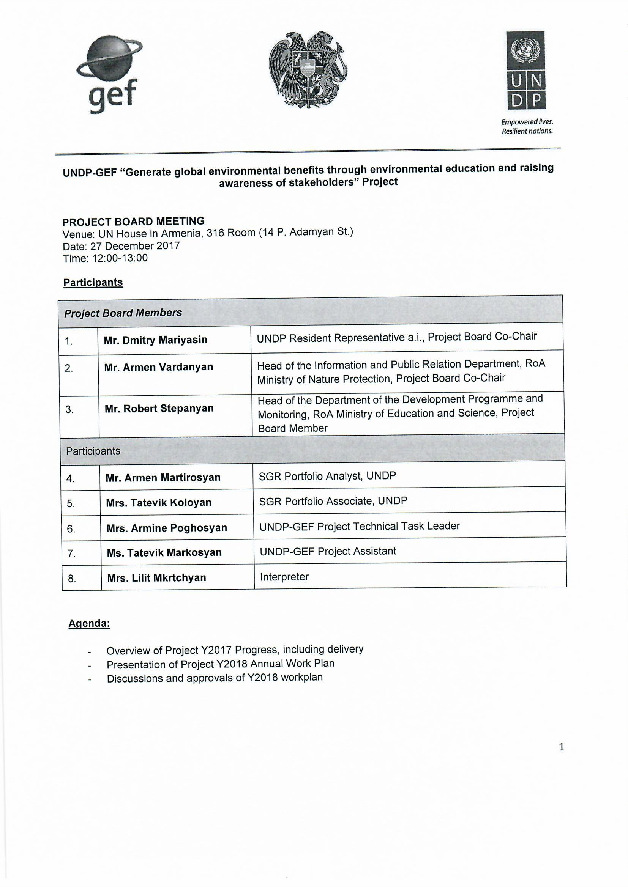
Annex B. Agenda, List of Participants and Minutes of the Project Board Meeting
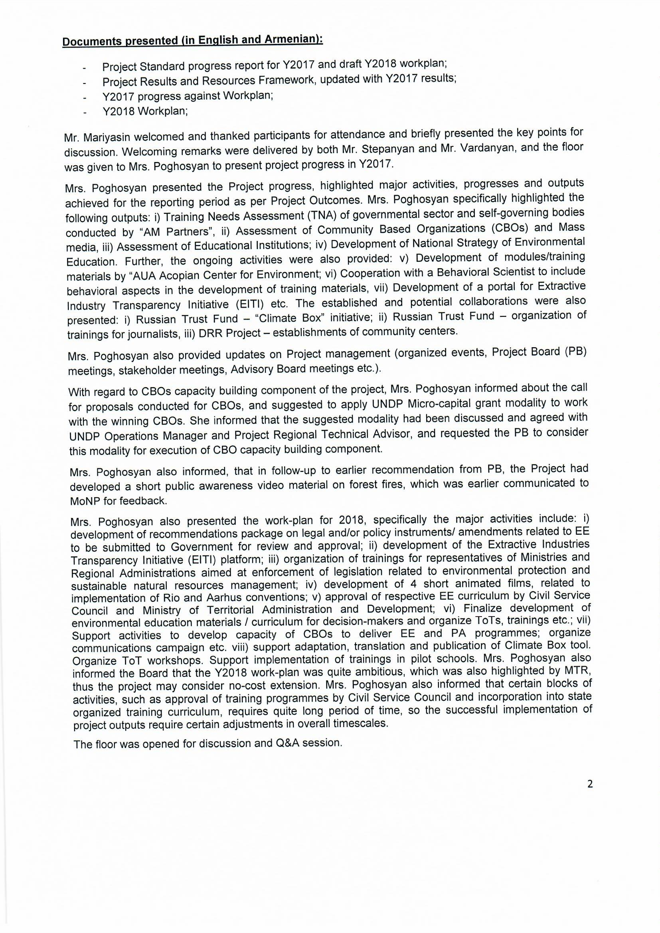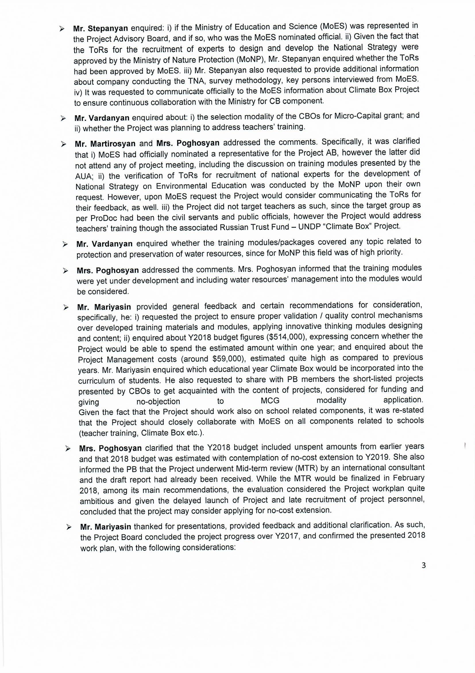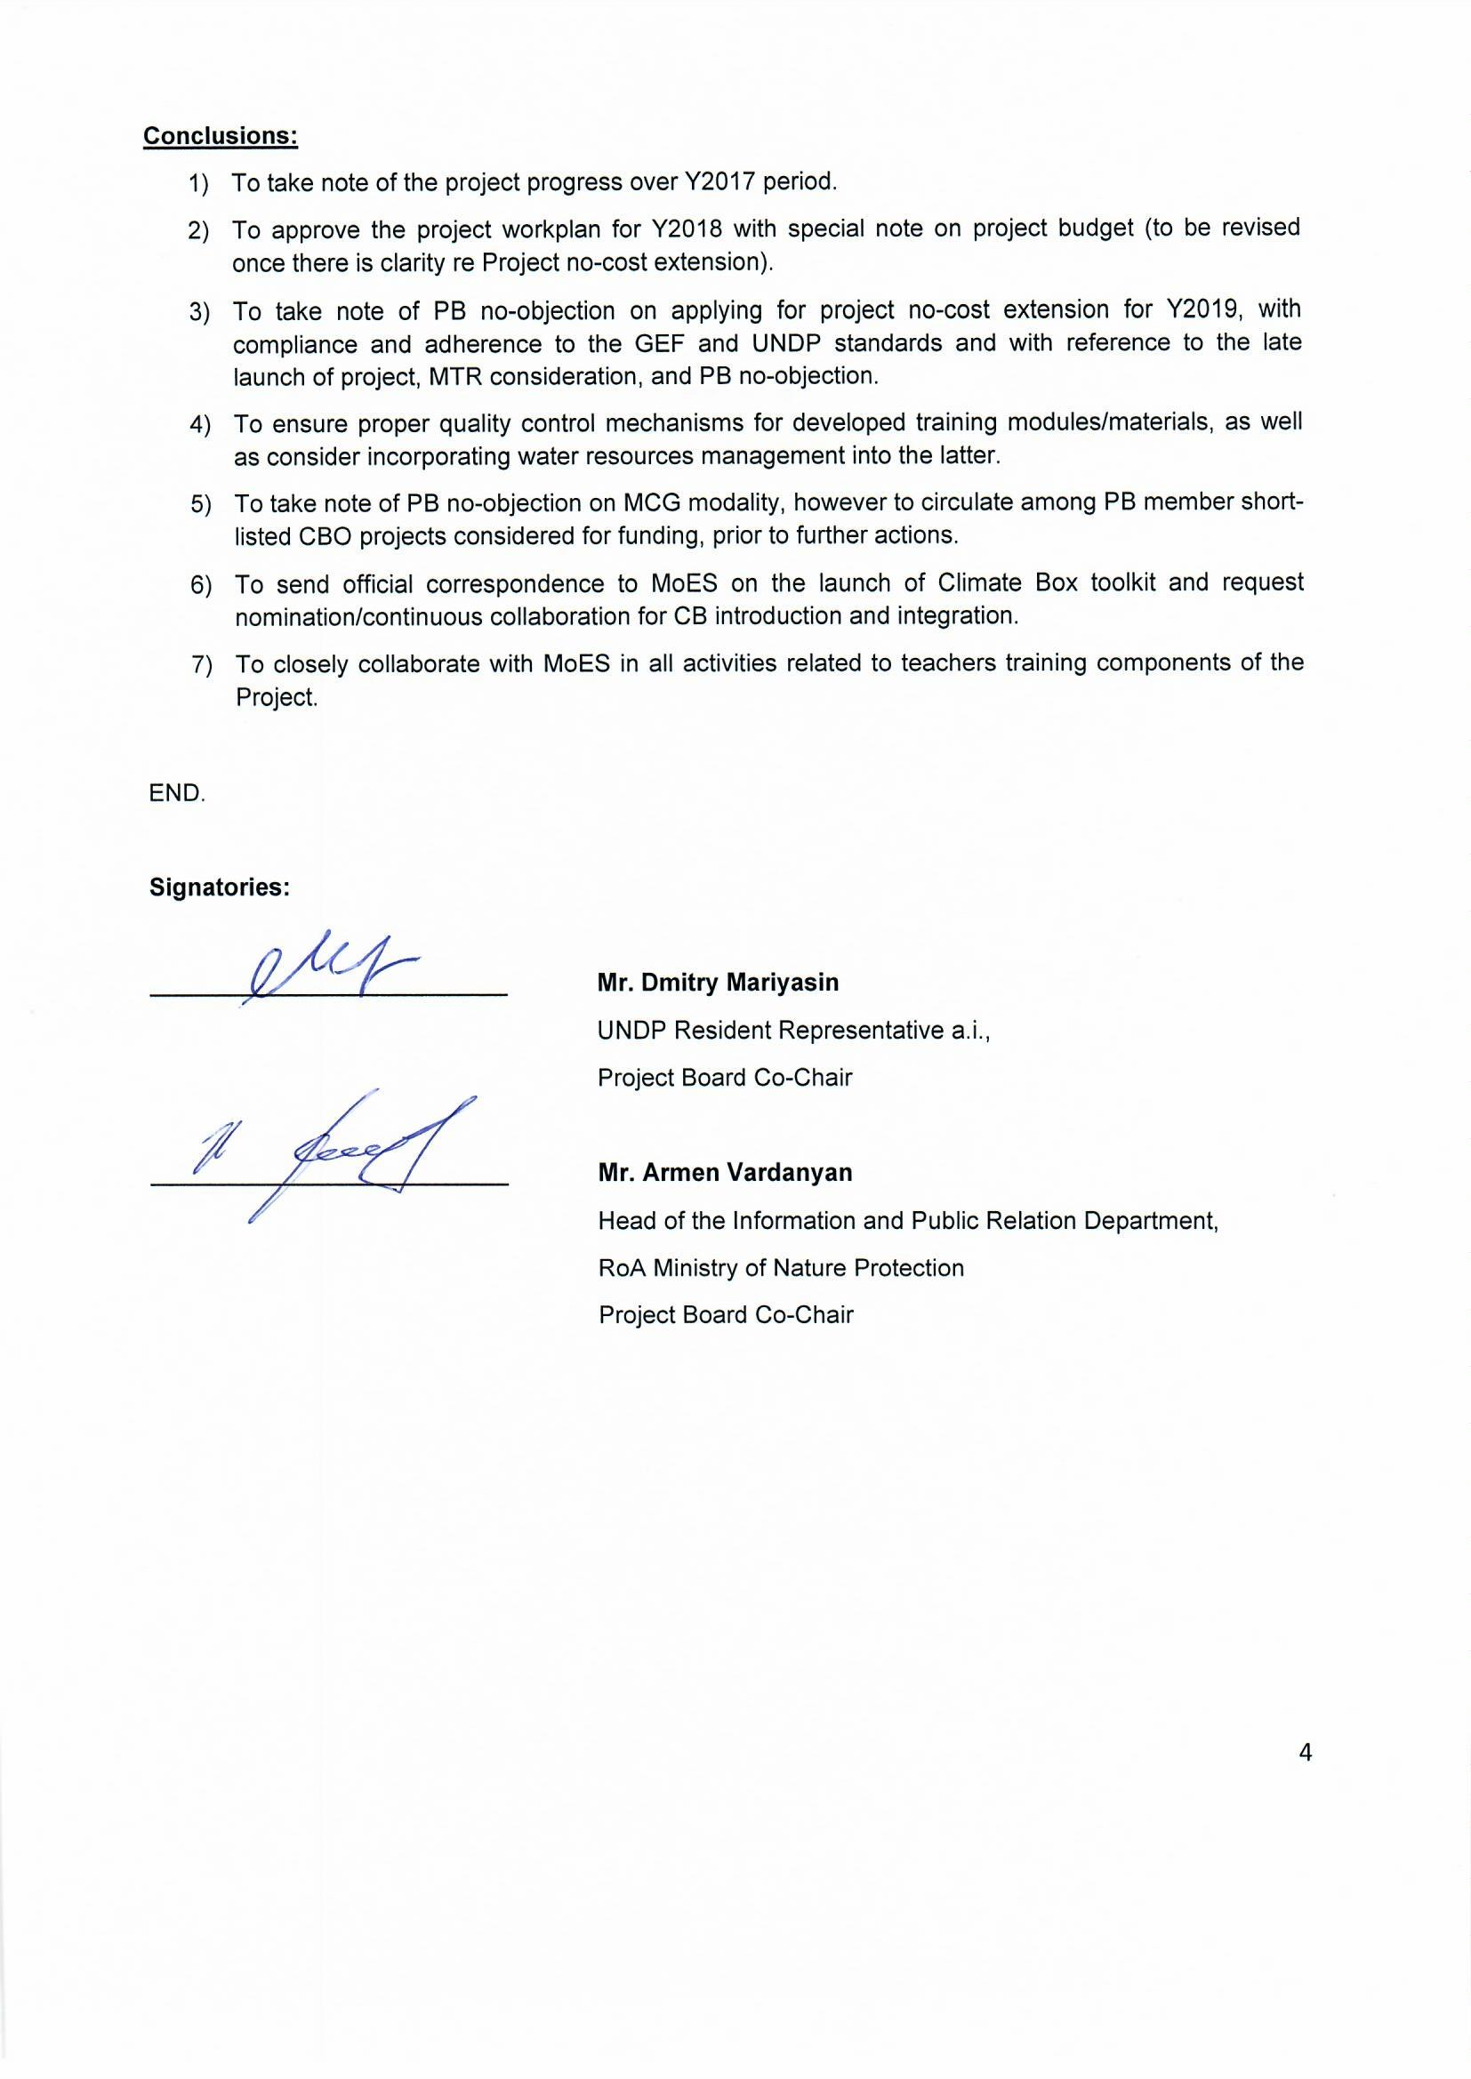
Annex C. Project Infographics
